**Website Information**

1. **Domain:** www.Ensofood.ca
2. **Website:**

Template: Strongly typed <https://html5up.net/strongly-typed>

1. Customization

* Color: Black and White
* Font: Same

1. Design

* Top options: Introduction, Projects, Careers, Contact Us
* Name: Enso Food Inc.
* 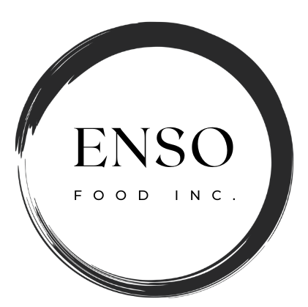Logo:
* Mission: "On a mission to revolutionize the food industry, we aim to bring diverse and delectable culinary experiences to people's lives and create a world where food is not just a necessity but a source of delight, connection, and innovation."

Short: Transforming the food industry by creating joy, connection, and innovation through diverse and delightful culinary experiences.

* Projects:
* **Bento Sushi – Raku Sushi:** Introducing Our Exciting Partnership with Bento Sushi: Fresh, Quality Sushi Coming to Calgary Walmart East Hill and Sobeys Forest Lawn!*(First Project Picture)*
* **Asian Fusion Hot Dog:** Introducing AsiaBite Hot Dogs - where traditional hot dogs embrace the rich, diverse flavors of Asian cuisine. Prepare for a mouthwatering fusion of taste and innovation. *(Second Project Picture)*
* **Asian Herbal Tea:** Welcome to 'Herbal Radiance Tea,' where centuries-old beauty secrets meet modern wellness. Our unique blend of herbs, cherished by royal courts and treasured by modern women, offers a holistic approach to enhancing your natural radiance." *(Third Project Picture)*

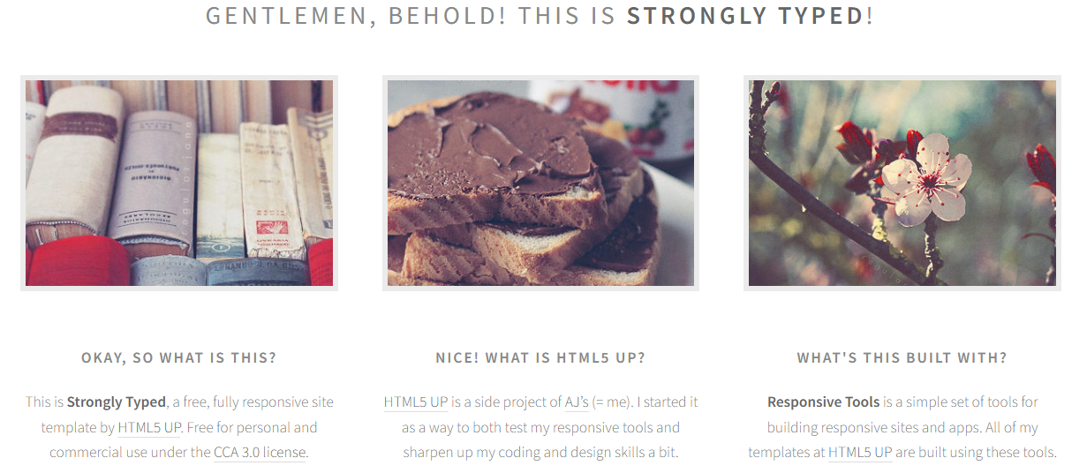

* Vison:

"Enso Food Inc. envisions a world where diverse and delicious culinary experiences bring people together, fostering cultural appreciation and culinary innovation. We strive to be a leading name in the food industry, promoting sustainability and creativity, while continuously delighting our customers with our unique offerings."

Short: "Enso Food Inc. strives to inspire global culinary delight through innovation and sustainability."

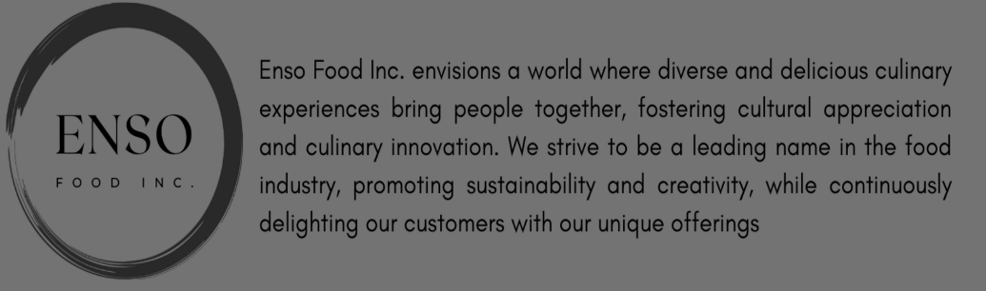

* **Bento Sushi – Raku Sushi**: Introducing our exciting partnership with Bento Inc. for Raku Sushi, located within Walmart East Hill at 255 East Hills Blvd SE, Calgary, AB, T2A 4X7 and Bento Sushi, located within Sobeys Forest Lawn at 5101 - 17 Avenue S.E.

Calgary, AB, T2A 0V7 - a venture that brings together the culinary expertise of Bento Inc. and the operational acumen of Enso Food Inc. As a subcontractor in this collaboration, we take on a pivotal role in managing day-to-day operations, focusing on delivering exceptional guest experiences at Sushi Store. Our commitment to excellence and innovation underpins this project, as we work together to shape the future of the sushi industry and bring diverse, delectable experiences to our valued customers in Calgary and beyond. *(Picture 4)*

* Asian Fusion Hot Dog: Welcome to AsiaBite Hot Dogs, where culinary creativity meets your cravings. Our fusion-style hot dogs redefine the classic, infusing them with vibrant Asian-inspired flavors and the finest high-quality ingredients. With a focus on fast, convenient service, we cater to those on the move without compromising on taste. Our affordable prices make exceptional dining accessible, and our commitment to personalized service ensures every bite is tailored to your preferences. Join us in savoring the extraordinary, one hot dog at a time. *(Picture 5)*
* Asian Herbal Tea: Welcome to "Herbal Radiance Tea." We offer a unique blend of herbs carefully crafted to nourish your inner beauty. Our tea combines delicate flowers, succulent fruits, and nurturing leaves, each chosen for its role in enhancing your natural radiance. "Trà Dưỡng Nhan," or "Herbal Radiance Tea," has a rich history, cherished as a beauty secret of royal courts. Today, it's a beloved treasure for women, with benefits extending beyond skin-deep beauty to skincare, hormonal balance, and more. Explore the world of "Herbal Radiance Tea" where ancient wisdom meets modern appreciation, nurturing your radiance from within. Join us on this journey to enhance your natural allure. *(Picture 6)*



* November 1st, 2023: Welcome to Raku Sushi at Walmart East Hill, where culinary innovation and passion unite. Our diverse sushi offerings are a result of the Bento Inc. and Enso Food Inc. partnership, dedicated to delivering unforgettable experiences.
* October 1st, 2023: Experience the essence of sushi excellence at Bento Sushi in Sobeys Forest Lawn, as we combine the art of sushi creation with operational expertise. Our commitment to innovation ensures a sushi journey that's diverse, delightful, and above all, satisfying.
* Something of Note:

Unlock the potential of the future with us! We're on a transformative journey in the world of culinary experiences, and we're inviting visionary investors to join us on this exciting path. Your investment can be the catalyst for innovation and growth, shaping the future of our company. Together, let's create something remarkable and reap the rewards of a thriving culinary venture. Contact us today to be a part of our culinary revolution!

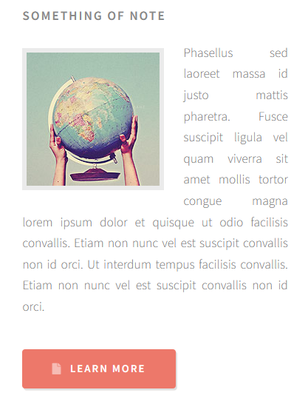

* Read more…
* QUESTIONS OR COMMENTS? GET IN TOUCH:

Address: 2715 12 Ave SE, Calgary, AB T2A 4X8

Phone: (647) 9130868

Email: ctrinh@ensofood.ca

Facebook: Enso Food

**Project 1:** **Bringing Fresh Sushi Delights to Walmart East Hill and Sobeys Forest Lawn with Bento Sushi Partnership**

In the world of culinary diversity, sushi has long held a special place as a beloved delicacy. It's a cuisine that marries the artistry of food preparation with the simplicity of fresh, quality ingredients. As we embark on an exciting project, we are thrilled to announce our partnership with Bento Sushi to bring this beloved cuisine to your local Walmart East Hill and Sobeys Forest Lawn locations.

**A Taste of Bento Sushi Excellence**

Bento Sushi is North America's fastest-growing sushi company, known for its commitment to quality, innovation, and an exceptional guest experience. With operations across the United States and Canada, Bento Sushi has established a reputation for crafting high-quality sushi that caters to a wide range of tastes and preferences.

**What You Can Expect**

At Walmart East Hill and Sobeys Forest Lawn, we are bringing the best of Bento Sushi right to your neighborhood. Here's a glimpse of what this exciting partnership will offer:

1. Fresh Sushi Creations: Bento Sushi is all about freshness. You can expect a wide variety of sushi creations prepared using the finest ingredients, ensuring a delightful and flavorful dining experience.

2. Diverse Menu Options: Whether you're a sushi connoisseur or new to this Japanese delight, our menu caters to all tastes. From classic rolls to innovative and contemporary sushi creations, there's something for everyone.

3. Exceptional Guest Service: Bento Sushi prides itself on delivering top-notch customer service. Our friendly and knowledgeable staff are committed to ensuring you have a memorable visit, whether you're dining in-store or grabbing a quick meal to go.

4. A Partnership That Cares: This partnership is not just about bringing great food to your local stores. It's about creating a positive impact on the community. By supporting this project, you're contributing to local job opportunities and helping us strengthen our community bonds.

**Your Culinary Adventure Awaits**

With Bento Sushi and our team, your culinary adventure awaits. We are excited to introduce you to a world of sushi flavors, where tradition and innovation meet to create an exceptional food experience. Whether you're a fan of classic sushi rolls or eager to explore new tastes, we invite you to join us in celebrating this partnership.

As we embark on this exciting project, we promise to deliver the freshest sushi, excellent service, and a memorable dining experience. Visit us at Calgary Walmart East Hill and Sobeys Forest Lawn to savor the delectable offerings from Bento Sushi, and experience a world of flavors right in your neighborhood.

Join us in celebrating this partnership and savoring the best of Bento Sushi in your community. Stay tuned for the grand opening, and get ready to embark on a sushi adventure like no other!

**Project 2:** **Introducing 'AsiaBite Hot Dogs': Where Tradition Meets Innovation in Every Bite**

**Who are we?**

Hello! We are Enso Food Inc., we are thrilled to introduce our upcoming venture, 'AsiaBite Hot Dogs.' At 'AsiaBite Hot Dogs,' we offer a tantalizing array of Asian fusion hot dogs, infusing the beloved classic with vibrant flavors inspired by various Asian cuisines. Our menu showcases a delightful fusion of ingredients, spices, and sauces that create a unique and unforgettable taste experience. We're dedicated to delivering a culinary adventure that will satisfy the cravings of food enthusiasts and offer a new perspective on the beloved hot dog.

**Who is our customers?**

We cater to a diverse range of customers, catering to various target markets. Our unique twist on the classic hot dog appeals to foodies passionate about exploring new and exciting culinary experiences, students seeking affordable and quick meals, professionals in need of convenient options, families looking for a fun dining experience, tourists seeking unique flavors, and event-goers desiring quick and delicious food.

**What sets us apart?**

**1. Authentic Asian Culinary Experience:** We're committed to providing an authentic Asian culinary experience. We understand the intricacies of Asian flavors, ingredients, and cooking techniques, ensuring that every dish we serve captures the essence of the region's cuisine.

**2. Fusion of Tradition and Innovation:** We pride ourselves on striking the perfect balance between tradition and innovation. While we respect and honor the traditional recipes and flavors of Asian cuisine, we also embrace creativity and experimentation.

**3. Quality and Sourcing:** We prioritize the quality of our ingredients and take great care in sourcing them. We partner with reputable suppliers who share our commitment to excellence, ensuring that our dishes are made with the freshest, highest-quality ingredients available.

**4. Health and Sustainability:** We recognize the importance of promoting healthy and sustainable eating habits. Our menu incorporates nutritious ingredients, and we prioritize environmentally friendly practices.

**5. Customer Satisfaction and Personalization:** Customer satisfaction is at the core of everything we do. We believe in providing exceptional service and ensuring that each customer's dining experience exceeds their expectations.

**6. Cultural Appreciation and Diversity:** We celebrate the rich cultural heritage of Asian cuisine and embrace its diversity. Our menu represents a wide range of Asian culinary traditions, allowing customers to explore different flavors and culinary journeys within a single establishment.

**Why choose 'AsiaBite Hot Dogs'?**

We invite you to choose 'AsiaBite Hot Dogs' for an unforgettable culinary journey. Our fusion-style hot dogs offer a unique blend of tradition and innovation, ensuring a delightful dining experience. We're dedicated to authenticity, quality, and customer satisfaction. Plus, our commitment to health and sustainability sets us apart. Join us for a delectable adventure that transcends the ordinary.

**Get in touch with us!**

**Project 3:** Title: "Nurturing Beauty from Within: Exploring the Wonders of 'Herbal Radiance Tea'"

In a bustling world where self-care and wellness take center stage, the quest for natural beauty has led many to seek ancient remedies and timeless traditions. 'Herbal Radiance Tea,' or "Trà Dưỡng Nhan," is one such hidden gem, offering a unique blend of herbs meticulously crafted to nourish your inner beauty and enhance your radiance from within.

"Herbal Radiance Tea" is a delightful fusion of delicate flowers, succulent fruits, and nurturing leaves, each meticulously chosen for its remarkable role in elevating your natural allure. This tea is not just about indulging in a soothing beverage; it's a journey to connect with age-old wisdom and the rich tapestry of traditions that surround it.

**A Beauty Secret Cherished by Royalty:**

The story of "Herbal Radiance Tea" is steeped in history. It was once a well-kept beauty secret of royal courts, a treasured elixir passed down through generations. These ancient queens and empresses understood the power of nature in enhancing beauty, and this knowledge has been preserved for modern seekers of wellness and radiance.

**A Treasure for Modern Women:**

Today, "Herbal Radiance Tea" has transcended the confines of history to become a beloved treasure for women of all walks of life. Its benefits extend far beyond skin-deep beauty, offering a holistic approach to well-being. As we delve into its composition, we discover a world of natural ingredients that cater to various aspects of health and radiance.

**Skincare Harmony:**

The carefully selected herbs in "Herbal Radiance Tea" are known to promote healthy and radiant skin. From reducing inflammation to combating acne, they work in harmony to address common skincare concerns, offering you a natural glow that can't be replicated by cosmetics alone.

**Hormonal Balance:**

Balancing hormones is essential for overall health and well-being. The herbal components in the tea are known to have a positive impact on hormonal balance, making it a valuable ally for women seeking equilibrium in their bodies.

**Embracing Tradition in a Modern World:**

In a fast-paced world, it's easy to overlook the wisdom of our ancestors. "Herbal Radiance Tea" invites you to reconnect with time-honored traditions and rituals. With every sip, you are not just enjoying a delicious beverage; you're savoring a piece of history, connecting with cultures that understood the secrets of beauty from within.

"Herbal Radiance Tea" is a testament to the age-old idea that true radiance comes from nourishing the body and soul. It's a bridge between ancient wisdom and modern appreciation, offering a holistic approach to well-being.

So, why wait? Embark on this journey with us and unlock the inner beauty that has always been within you. "Herbal Radiance Tea" is more than a beverage; it's a gateway to a more radiant and balanced you. Join us in nurturing your natural allure, sip by sip, and let the ancient secrets of beauty unfold in your life.